**Implementing the C# code for the Speedometer and character**

First, add in the images of your character and floor (both cannot be provided by Unity as it will not work), then add the Character Movement script component into the character game object in the hierarchy. Then add a **Ridgidbody 2D component** and a 2D Collider component into the character (Circle Collider 2D or Box Collider 2D depending on shape) so the script will be able to move the character through the Rigidbody and stop the character from falling through the floor and wall (if you decide to add a wall). The floor must also contain a 2D collider, but **not** a Rigidbody.

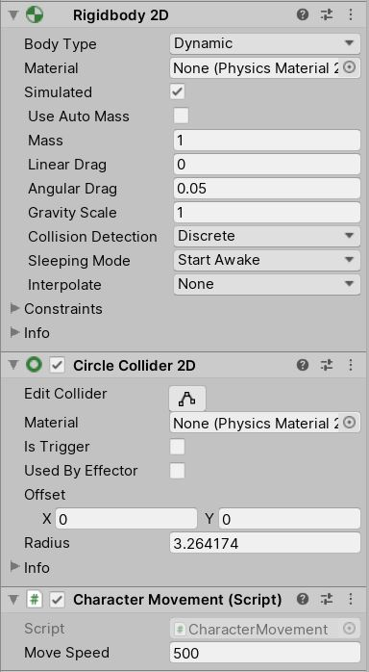

The collider **must not be set to be a trigger** on either the character or the floor and wall, as that also allows the character to go through them. How fast the character moves **is up to you**.

Afterwards, add the Character Tailored Speedometer into the speedometer while it has **needle 3** attached as the moving needle, otherwise it will start in the wrong position.

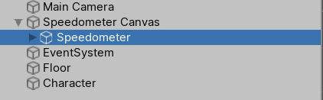

The highlighted game object **must** be the one that gets the **Character Tailored Speedometer script component** added to it.

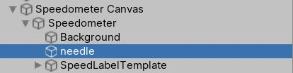

The **Source Image** for the needle must be the one that has the number **3**, as that image is the one that starts at 0.

Finally, where it says “Object to Measure” in the Speedometer game object, **drag the character from the hierarchy into that section of the component** and then the speedometer will calculate the speed of the character’s movement through the Rigidbody’s movement while the scene is playing. Make sure that Disallow Backwards is ticked so the speedometer **cannot calculate below 0**.

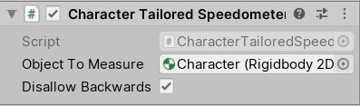

If the character **does not** have the **rigidbody2D component** added to it, the character **will not** be able to be implemented in the Object To Measure part of the script and will not be able to calculate the character’s speed in the game.